# Lab: Objects and Classes

Problems for exercise and homework for the ["JS Fundamentals" Course @ SoftUni.](https://softuni.bg/trainings/4221/programming-fundamentals-with-javascript-september-2023)   
Submit your solutions in the SoftUni judge system at: <https://judge.softuni.org/Contests/1323>

## Person Info

Write a function that receives **3 parameters**, sets them to an **object**, and **returns** that object.

The input comes as **3 separate strings** in the following order: **firstName**, **lastName**, **age**.

### Examples

|  |  |
| --- | --- |
| **Input** | **Object Properties** |
| **"Peter",  "Pan", "20"** | **firstName: Peter**  **lastName: Pan**  **age: 20** |
| **"George",  "Smith", "18"** | **firstName: George**  **lastName: Smith**  **age: 18** |

### Hints

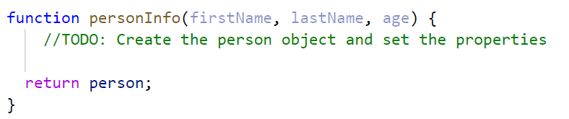

## City

Write a function that receives a **single** **parameter** – an **object**, containing **five properties**:

**{ name, area, population, country, postcode }**

Loop through all the **keys** and **print** them with their **values** in format: "**{key} -> {value}**"

See the examples below.

### Examples

|  |  |
| --- | --- |
| **Input** | **Output** |
| **{**  **name: "Sofia",**  **area: 492,**  **population: 1238438,**  **country: "Bulgaria",**  **postCode: "1000"**  **}** | **name -> Sofia**  **area -> 492**  **population -> 1238438**  **country -> Bulgaria**  **postCode -> 1000** |
| **{**  **name: "Plovdiv",**  **area: 389,**  **population: 1162358,**  **country: "Bulgaria",**  **postCode: "4000"**  **}** | **name -> Plovdiv**  **area -> 389**  **population -> 1162358**  **country -> Bulgaria**  **postCode -> 4000** |

## Convert to Object

Write a function that receives a **string** in **JSON format** and converts it to an **object**.

Loop through all the keys and print them with their values in format: "**{key}: {value}**"

### Examples

|  |  |
| --- | --- |
| **Input** | **Output** |
| **'{"name": "George", "age": 40, "town": "Sofia"}'** | **name: George**  **age: 40**  **town: Sofia** |
| **'{"name": "Peter", "age": 35, "town": "Plovdiv"}'** | **name: Peter**  **age: 35**  **town: Plovdiv** |

### Hints

* Use **JSON.parse()** method to parse JSON string to an object

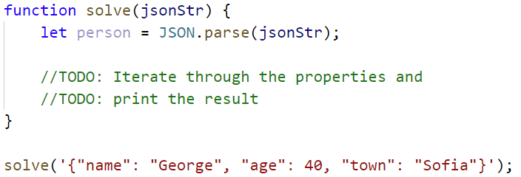

## Convert to JSON

Write a function that receives a **first name**, **last name**, **hair color** and sets them to an **object**.

Convert the **object** to **JSON string** and print it.

Input is provided as **3 single strings** in the order stated above.

### Examples

|  |  |
| --- | --- |
| **Input** | **Output** |
| **'George', 'Jones', 'Brown'** | **{"name":"George","lastName":"Jones","hairColor":"Brown"}** |
| **'Peter', 'Smith', 'Blond'** | **{"name":"Peter","lastName":"Smith","hairColor":"Blond"}** |

### Hints

* Use **JSON.stringify()** to parse the object to JSON string

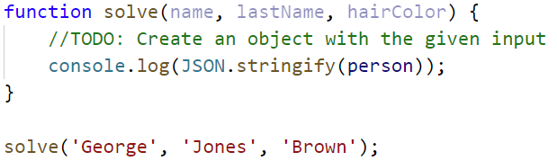

## Cats

Write a function that receives **array** of strings in the following format **'{cat name} {age}'**.

Create a **Cat** **class** that receives in the **constructor** the **name** and the **age** parsed from the input.

It should also have a method named **"meow"** that will print **"{cat name}, age {age} says Meow"** on the console.

For each of the strings provided, you must **create a cat object** and invoke the **.meow ()** method**.**

### Examples

|  |  |
| --- | --- |
| **Input** | **Output** |
| **['Mellow 2', 'Tom 5']** | **Mellow, age 2 says Meow**  **Tom, age 5 says Meow** |
| **['Candy 1', 'Poppy 3', 'Nyx 2']** | **Candy, age 1 says Meow**  **Poppy, age 3 says Meow**  **Nyx, age 2 says Meow** |

### Hints

* Create a **Cat class** with properties and methods described above
* Parse the input data
* Create all objects using the class constructor and the parsed input data, store them in an array
* Loop through the array using **for…of** a cycle and **invoke .meow()** method

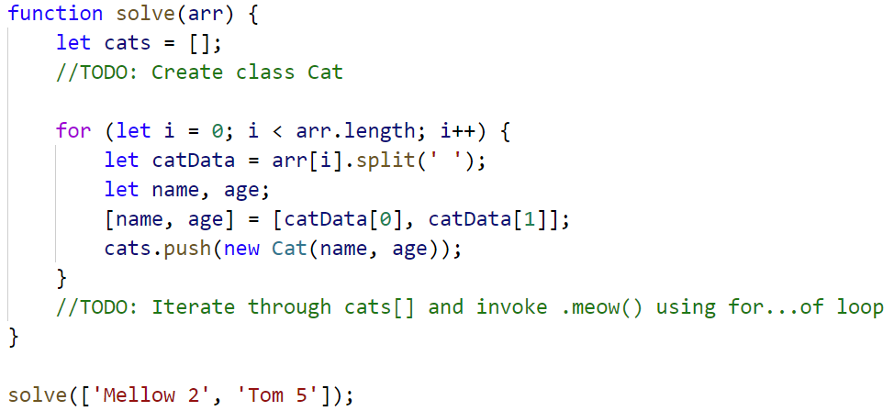

## Songs

Define a **class** **Song**, which holds the following information about songs: **typeList**, **name,** and **time**.

You will receive the input as an **array**.

The first element **n** will be the number of songs. Next **n** elements will be the songs data in the following format: **"{typeList}_{name}_{time}"**, and the last element will be **typeList** / **"all".**

Print only the **names of the songs**, which have the same **typeList (**obtained as the last parameter**)**. If the value ofthe last element is **"all",** print the names of all the songs.

**Examples**

|  |  |
| --- | --- |
| **Input** | **Output** |
| **[3,**  **'favourite_DownTown_3:14',**  **'favourite_Kiss_4:16',**  **'favourite_Smooth Criminal_4:01',**  **'favourite']** | **DownTown**  **Kiss**  **Smooth Criminal** |
| **[4,**  **'favourite_DownTown_3:14',**  **'listenLater_Andalouse_3:24',**  **'favourite_In To The Night_3:58',**  **'favourite_Live It Up_3:48',**  **'listenLater']** | **Andalouse** |
| **[2,**  **'like_Replay_3:15',**  **'ban_Photoshop_3:48',**  **'all']** | **Replay**  **Photoshop** |

### Solution:

Create a **Song class** with properties described above

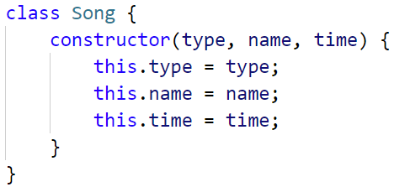

Create a new array, where you will store songs

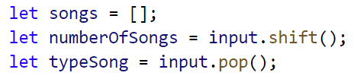

Iterate over the songs:

